**Comparison of Government Healthcare Expenditure and Out-of-Pocket Expenditure Across Countries in Different Socioeconomic Levels**

Sreeti Ravi and Yuke Liu

**Abstract**

In this project, we will look at the health expenditures of various countries around the world and compare that to the amount the people within the country have to spend. We want to compare a government’s healthcare expenditure and how much people have to spend out-of-pocket in relation to how much a government spends, so if a government is spending more do people able to spend less on healthcare out-of-pocket? Government expenditure on health is made up of the direct outlays earmarked for the enhancement of the health status of the population and the distribution of medical care goods and services among the population by central, federal, state, provincial, local and municipal authorities, extrabudgetary agencies and social security schemes (OECD). Out-of-pocket payments are defined as direct payments made by individuals to health care providers at the time of service use (Out-of-pocket). We will also look at the distribution of expenditure over different income levels to see if there are any trends.

**Introduction:**  why your project is important or interesting? Why should we care?

Much of the growth in health care spending over the past twenty years is linked to modifiable population risk factors such as obesity and stress. Rising disease prevalence and new medical treatments account for nearly two-thirds of the rise in spending. Growth in spending has also been linked to the rising use of prescription drugs and new medical innovations and treatments. Studies have shown that the United States spends a lot more on health care than any other high-income countries and that is due to higher administration expenses. The US spends 18% of its annual GDP on health and the next country with the highest health spending is Sweden at 12%. Most other countries spend around 9% of their GDP on health. The United States spends more per person on healthcare than the next 12 high income nations. Other wealthy countries spend about half as much per person on healthcare than the US. Relative to wealth, the US spends a disproportionate amount on health care and is constantly an outlier when it comes to health spending.

We should care about rising health care costs and how much our government is spending on healthcare because whether we want to or not, we all rely on healthcare services in one form or another. Most people go to at least one doctor regularly and we will end up going there at some point in our lives. We should know what we are paying for and should be educated on why exactly we are paying so much in the US for the same services that are much cheaper in other countries. While we are paying these increased prices, life expectancy and quality of healthcare in the US has not increased proportionally and other countries have better statistics when it comes to things like obesity, life expectancy, death rate, etc.

**Background and related work**

We found a lot of existing visuals showing varying health expenditure per capita across the world. A lot of the examples we found were heat maps on a world map such as the following one.

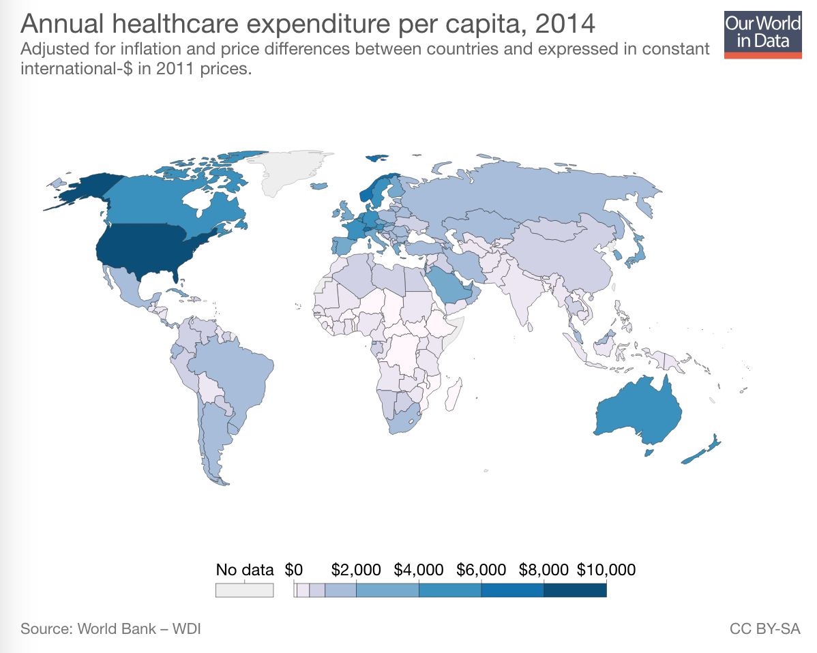

We liked that this visualization showed how the US spent much more money than the other countries because the color contrast was so drastic. A heat map was a good way to show data across all countries. A bar graph or anything else would have been too large and not as easy to look at. We did not like how couldn’t figure out exactly how much each country spent. We could ballpark based on the colors but we could not get specifics from this visualization.

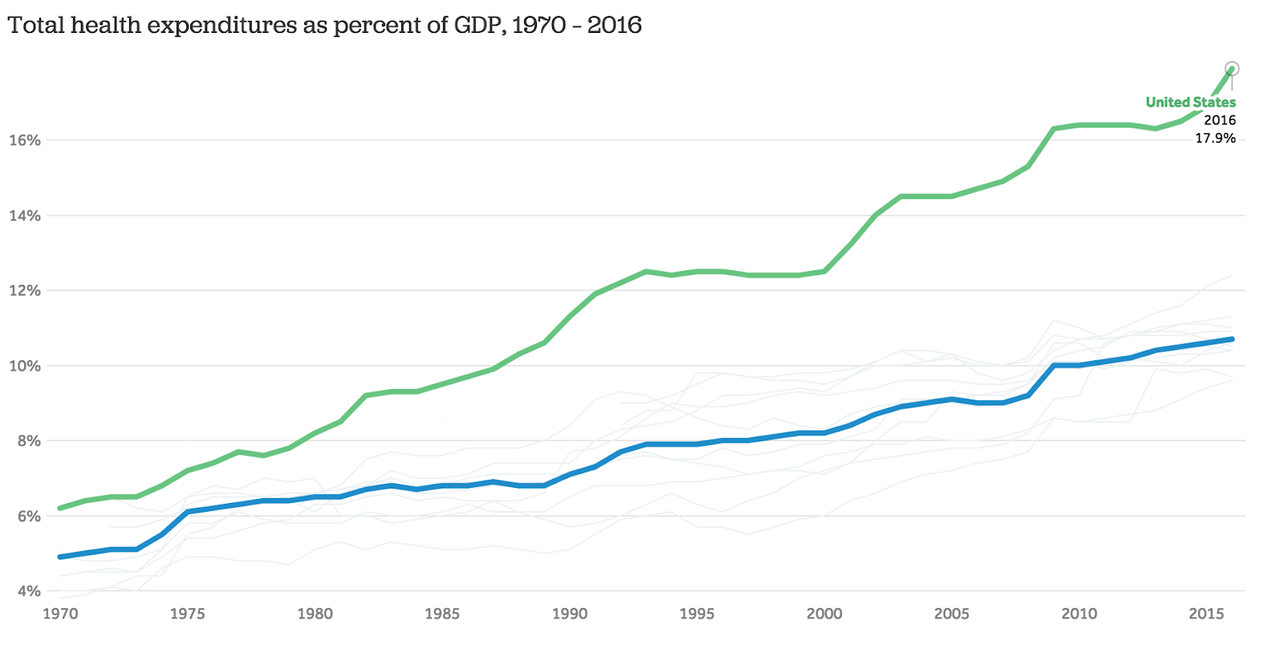

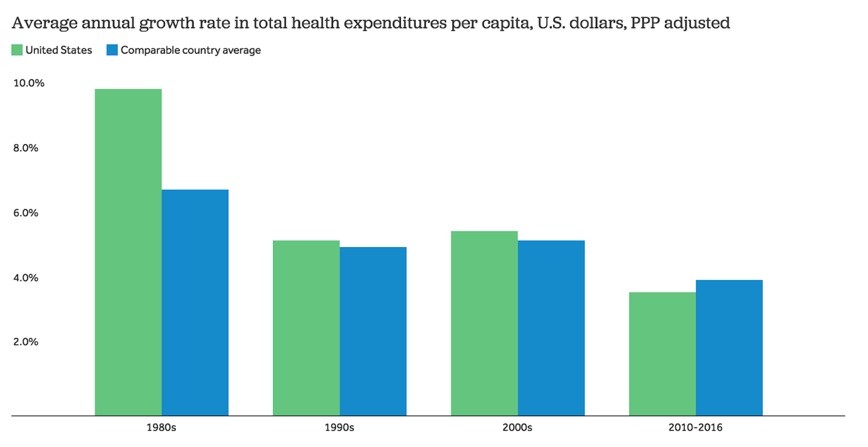

These two did a good job of showing how the US spent a disproportionate amount compared to the other countries. We liked that the second visualization had a hover feature, so if you hovered over the faint gray lines you could find out what country and what percent of the GDP the country spent on healthcare. The blue line was an average of all the other countries. We liked how this visualization highlighted the two main lines in bolder colors and made the rest faint, but also gave people the option to look at that data as well. The last one showed the change in growth rate in total health expenditure per capita and showed how the US had a decreasing growth rate, but when put in perspective to other visualizations we found it made sense because the US spent more money from the beginning. We liked that these visualizations were easy to read and showed clear trends and results.

There is not much that we found comparing the general government healthcare expenditure and out-of-pocket expenditure for individuals. There should be more visualizations directly comparing the two because it is important to see how a government’s expenditure influences private spending, also known as out-of-pocket expenditure.

**Research questions, hypothesis, or objectives**

We want to look at whether there is a correlation between how much a country spends on healthcare and how much people have to pay out-of-pocket and how much more the US spends than other countries. We will also compare healthcare expenditure of different countries of different socioeconomic status using data over the last fifteen years. Most of our research has shown us that the US spends drastically more than every other country and almost twice as much as the next 10 most developed countries. Our hypothesis is that if a country spends more, the people in it would have to spend less. We predict that less developed countries spend more on healthcare and individuals spend less because they need easier access to healthcare and developed countries spend more on healthcare and people do to because of the higher pricing of healthcare facilities.

**Process and Results**

We started by importing a dataset from the World Health Organization, but it contained data for 193 countries which was too many so we narrowed down the dataset by choosing a few countries from regions defined by the World Health Organization. Within each region, we made sure to choose countries of varying socioeconomic levels. We narrowed down the columns to include only the data we needed, so we used country name, indicators, year and value. This is what a few columns of the dataset looked like:

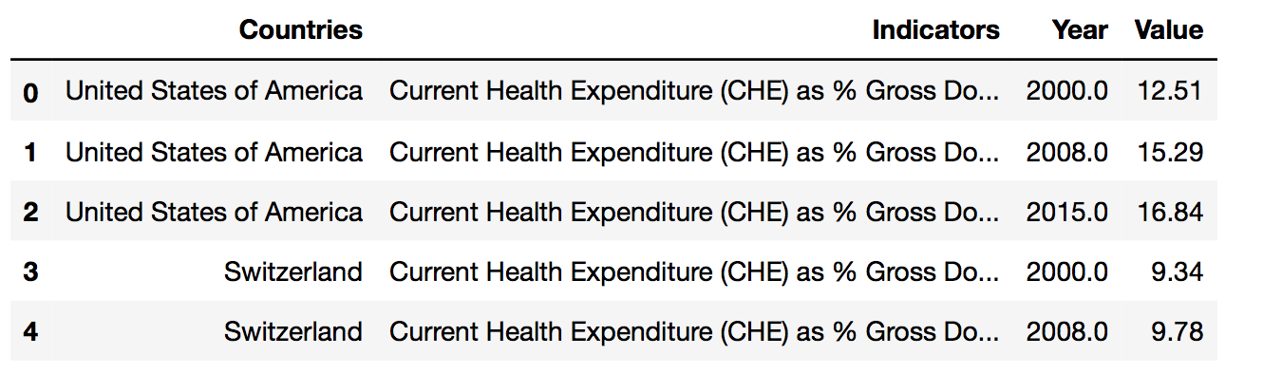

We used a stacked bar graph to compare the current health expenditure as a percent of the gross domestic product of the countries we chose over three years. We wanted to compare the domestic general government health expenditure per capita to out-of-pocket expenditure per capita over three years so we used a line graph and this is what we got:

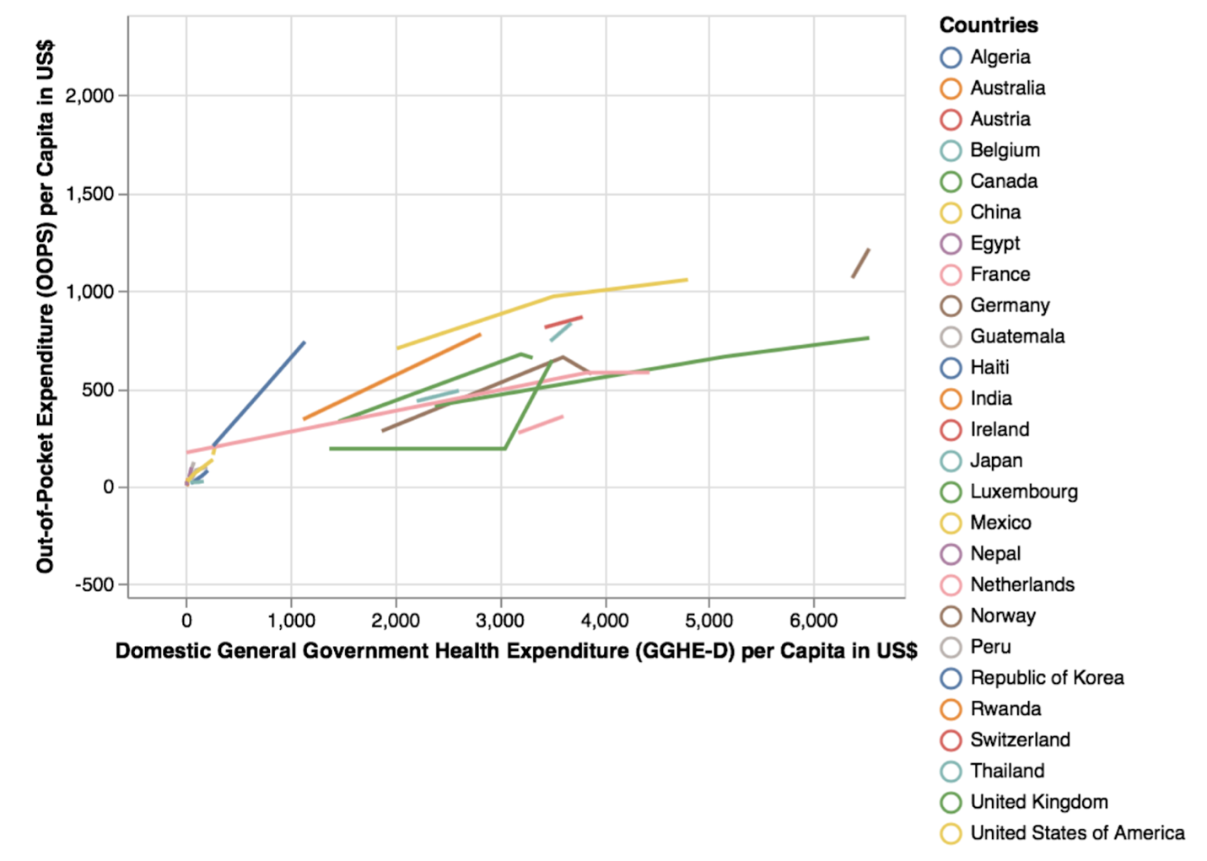

This graph is very hard to read because there are too many countries and some countries have less change than others, so the lines are much smaller. The data is all over the place and there are no visible trends. Overall, it is not a very good graph and was not the best way to present the information, so we narrowed the number of countries down but made sure that every region and all the socioeconomic levels were still represented and made a scatterplot of the data from just one year.

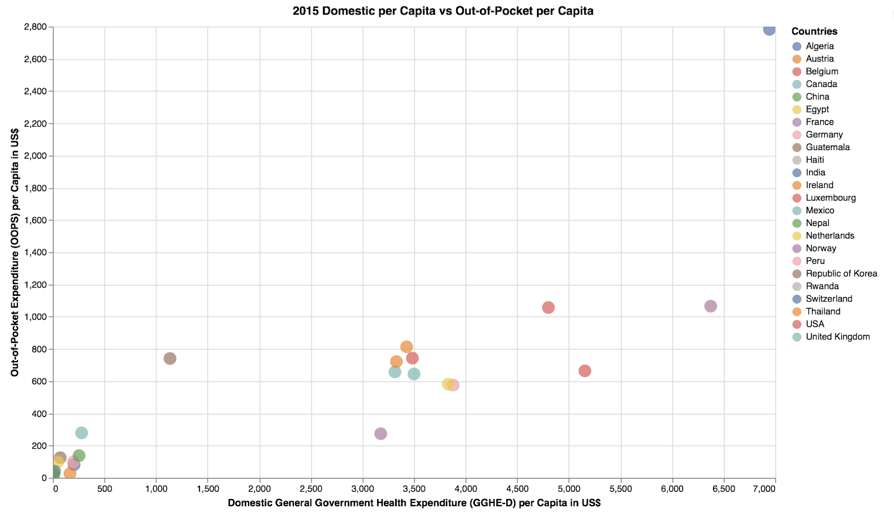

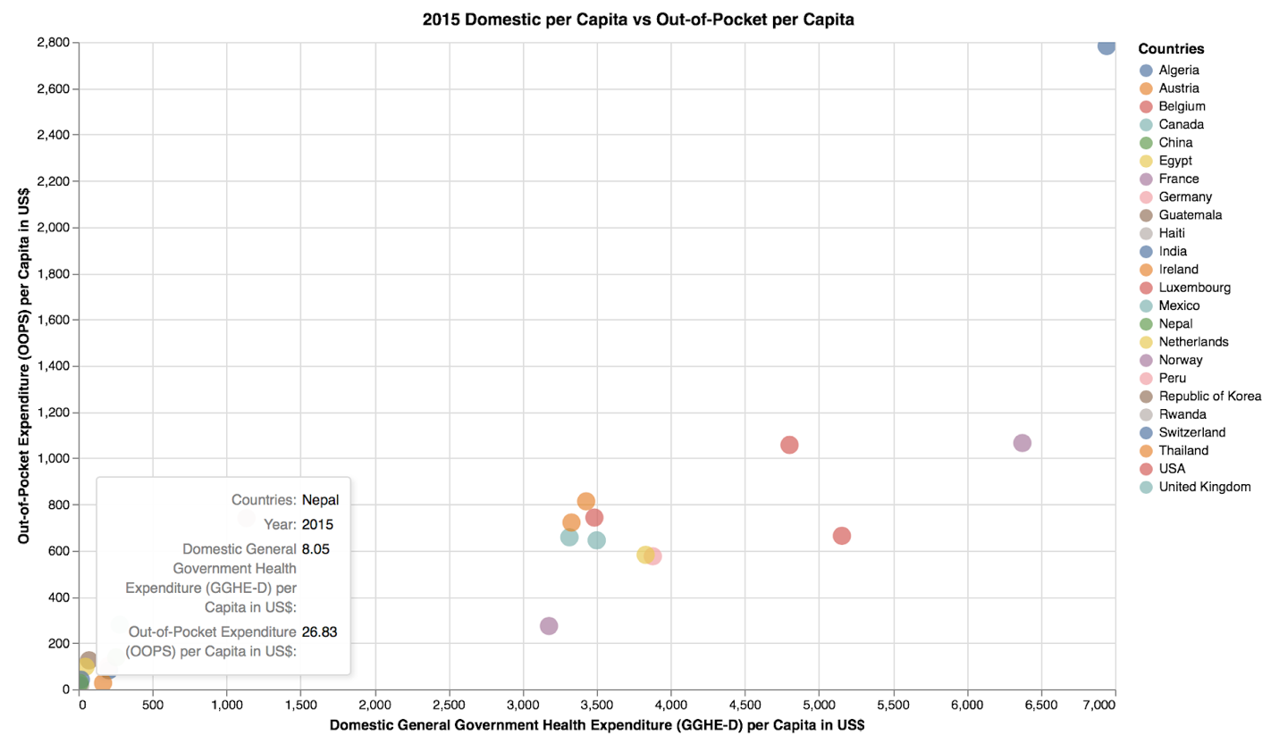

This scatterplot is a much easier graph to read and because the colors can be hard to figure out, we made sure there was a hover option. When you hover over a dot, you get a textbox that gives you the name of the county, year, domestic general government health expenditure and out-of-pocket expenditure. In this graph, we can see that Switzerland has the highest expenditure by government and out-of-pocket, while Nepal has the smallest of both. The US is the red dot and not necessarily the only outlier like our research has suggested. While this represents each country’s data, it does not show the socioeconomic levels of each country so we made a line graph to show the growth of expenditure based on income group and this was the resulting graph:

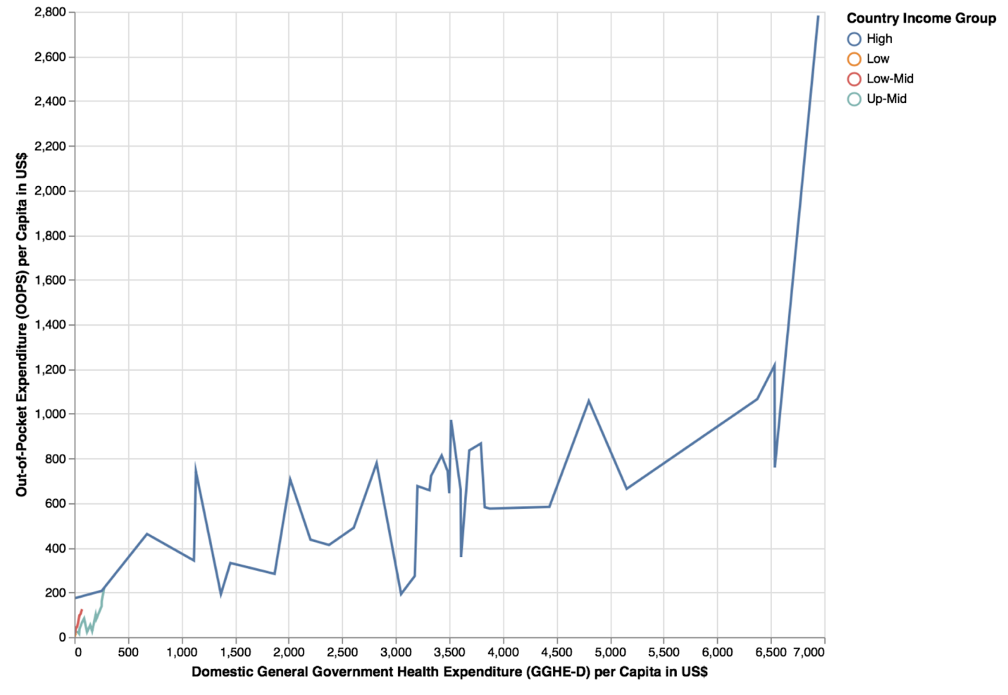

The only easily visible line is the one for high income group and there was not enough data for the lower income group lines for it to extend all the way. Because this is not the best way to show this data, we made a similar scatterplot as before for different income groups using data for only 2015.

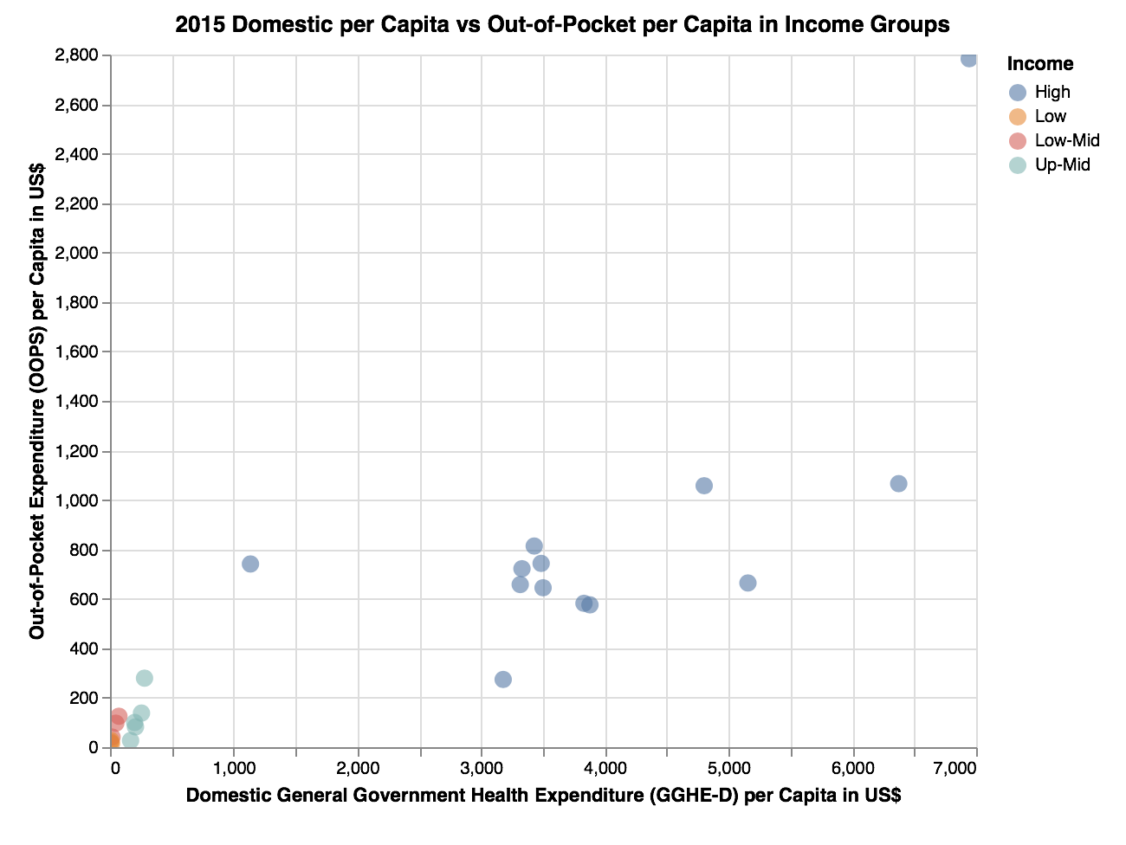

This scatterplot makes it easier to see the data and the difference in spending by income groups. Here, we can see that the higher income groups have a higher health expenditure by the government and higher out-of-pocket costs. The other three income groups are all in the bottom left hand corner because they have the smallest amount of spending by both the government and people. This graph shows a clear distinction with spending and income groups that suggests more developed countries have a higher general government health expenditure per capita and higher out-of-pocket expenditure per capita. We also made a 1D scatter plot to show this same data in a different manner, which further confirmed that the more developed countries have more out-of-pocket costs.

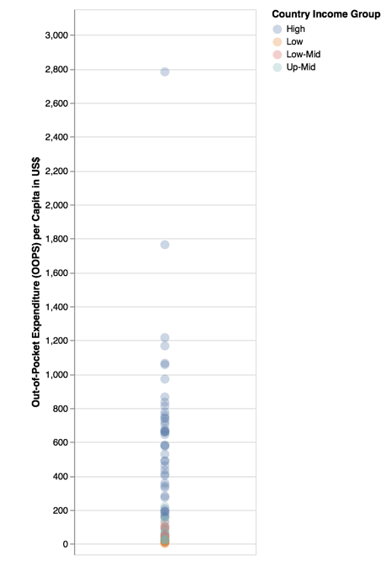

To show the out-of-pocket expenditure, we used a bar graph in which we narrowed down the list of countries even further.

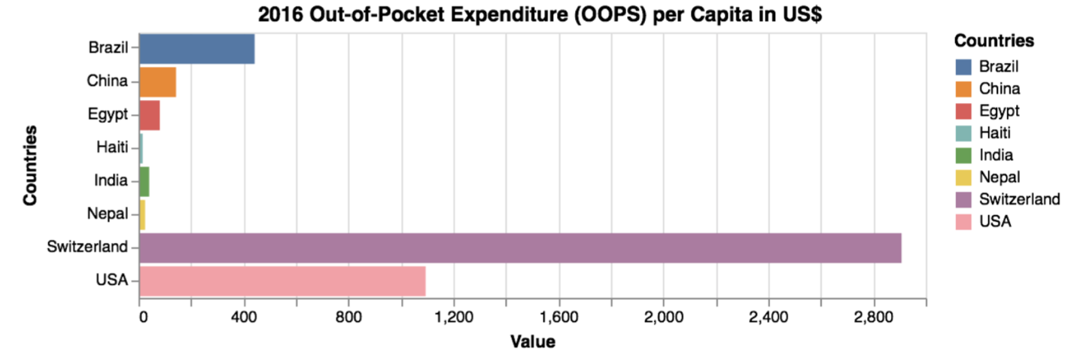

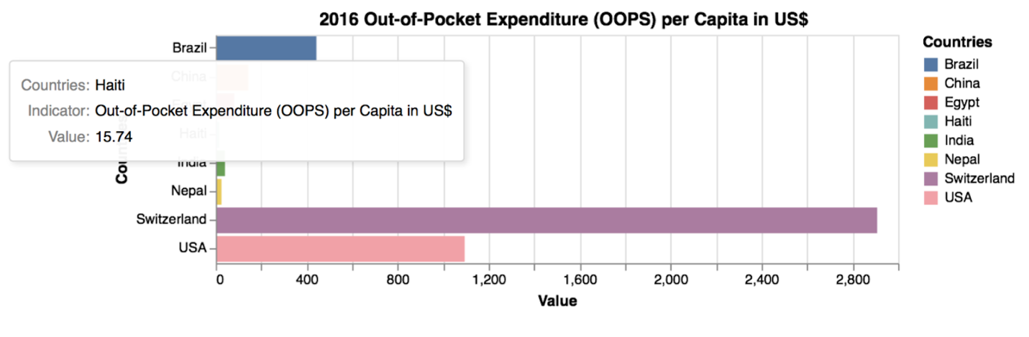

We included the hover feature here as well so the value would not be difficult to figure out. In this graph, we can see that Switzerland has higher out-of-pocket costs than the US, which would suggest that the US is not the outlier. The US and Switzerland do having quite larger out-of-pocket expenses. Lastly we made a stacked bar graph for the same countries to show out-of-pocket expenditure per capita by income groups.

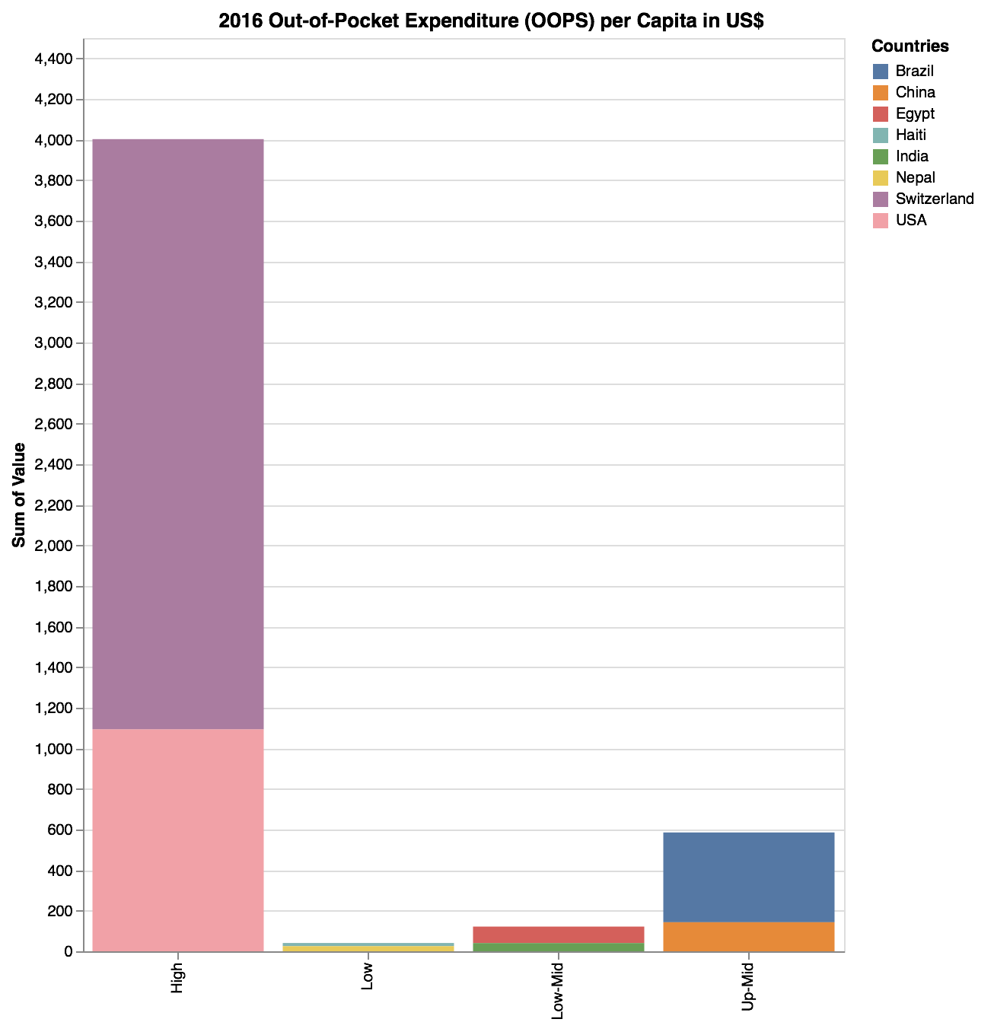

In this graph, you can see that the US spends less than half of what Switzerland does and could suggest that the US does not spend the most on healthcare. There is obviously a clear difference between high-income level countries and all the other income levels. Our hypothesis was half wrong because countries of higher income levels spend more on healthcare and out-of-pocket expenses are higher as well. Countries of lower income levels have lower government expenditure and people have lower out-of-pocket costs as well. Our visualizations show different results than what we read during our research. Our visualizations show that the US is not an outlier and that the US is actually not spending the most. We discovered that in lesser developed countries, the government is spending less on healthcare than developed countries and people are spending less out-of-pocket than more developed countries. This could be due to a lot of factors. Data and visualizations that we found online could be taking into consideration other factors like obesity, diabetes and other health factors. In the future we would take all of this into consideration and use other data as well to make more inclusive visualizations.

**References**

Berezoq, Alex. “Cost & Payments: Two Peculiarities of US Healthcare Spending.” *American Council on Science and Health*, 25 Apr. 2017.

Bloom, Ester. “Here’s How Much the Average American Spends on Health Care.” *CNBC,* CNBC, 23 June 2017.

Ducharme, Jamie. “The U.S. Spends Twice As Much On Health Care As Other High-Income Countries.” *Time,* Time, 13 Mar. 2018.

“Global Health Expenditure Database.” *World Health Organization,* World Health Organization.

OECD (2018), Health spending (indicator). doi: 10.1787/8643de7e-en (Accessed on 14 December 2018).

“Out-of-Pocket Payments, User Fees and Catastrophic Expenditure.” *World Health Organization,* World Health Organization, 6 Apr. 2018.

Rizzo, Kevin. “How Much Does the Government Spend on Health Care?” *Law Street,* 24 July 2017.

Sawyer, Bradley, and Cynthia Cox. “How Does Health Spending in the U.S. Compare to Other Countries?” *Peterson-Kaiser Health System Tracker,* Kaiser Family Foundation, 7 Dec. 2018.